Aerial View of the Quality Road Manufacturing Facility



**QUALITY ROAD, SINGAPORE**

Quality Road, Singapore is an established facility for the manufacture of Amoxicillin Trihydrate and Monosodium Ticarcillin. This is a GlaxoSmithKline site that suppliers customers worldwide. The site is operated by a highly competent and dedicated team of employees who are focused on delivering the best medicine that ensures patient safety. The Quality Road facility is one of the largest Amoxicillin manufacturing facilities in the world. It is equipped with computer controlled system, which provides fine control of the process parameters to deliver consistent product quality.



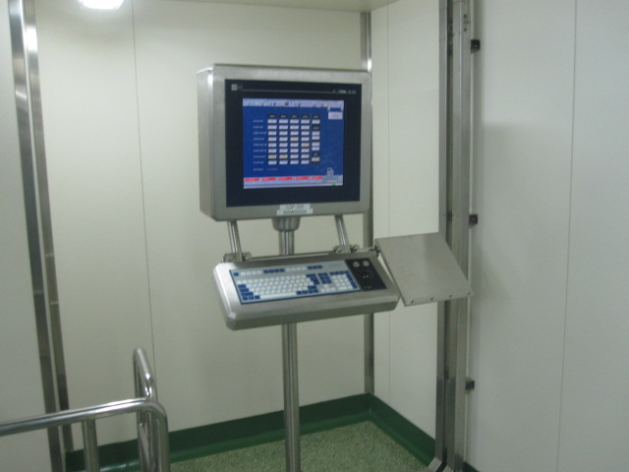

**Key Capabilities**

* Global cGMP facility with development capability to perform optimisation studies
* Capable of full analytical testing for physical, chemical and microbiological properties
* Able to increase capacity by operating more process trains
* Capable of producing pelletised to milled Amoxicillin Trihydate that are suitable for syrups, tablets and capsules
* Able to response promptly from manufacturing to testing and full release
* Experience in internal and external third party sales

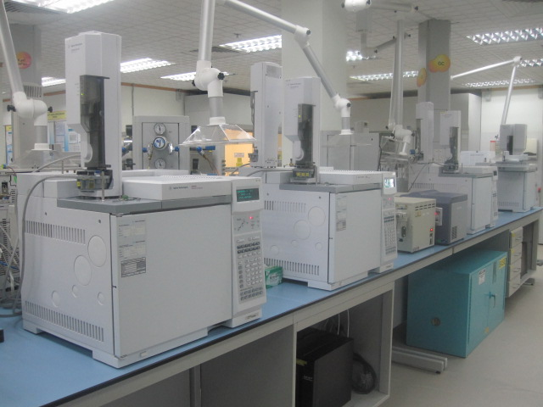

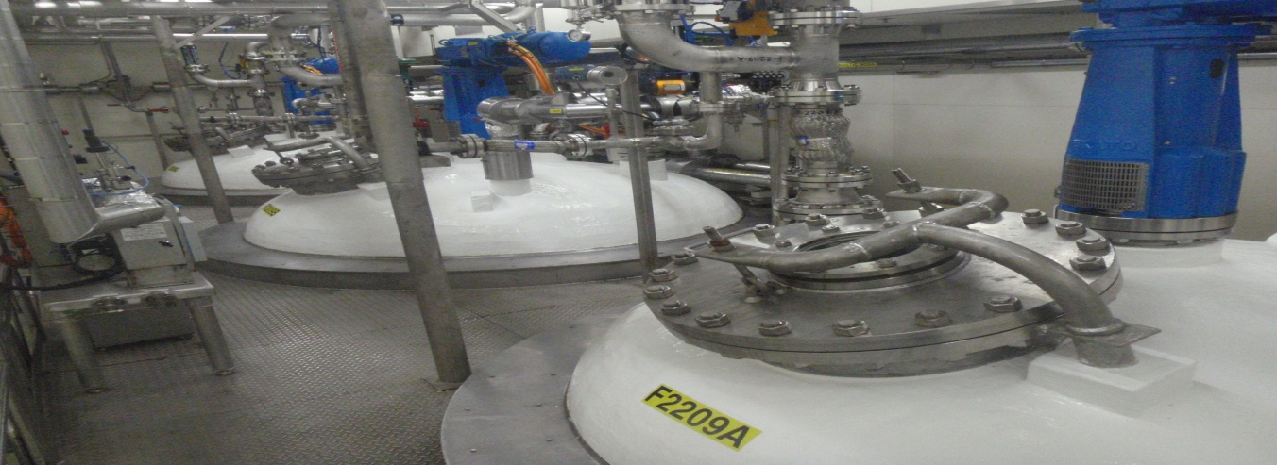

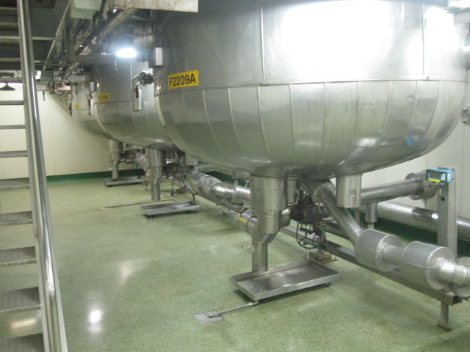

**Products**

The GlaxoSmithKline facility at Quality Road is dedicated for the manufacture of the Active Pharmaceutical Ingredient (API) for Amoxil® and Augmentin® as well as an intermediate, monosodium ticarcillin, for conversion to disodium ticarcillin, the API for Timentin®. The site supplies customers worldwide (e.g. USA, Europe, Asia Pacific, Middle East , Africa, etc).

Augmentin® is a broad-spectrum antibacterial suitable for the treatment of a wide range of common bacterial infections. It is a combination of a β-lactam antibacterial (Amoxicillin, which is produced in Singapore) and a β-actamase inhibitor (clavulanate). Amoxicillin is a chemically enhanced version of penicillin that has a high level of activity against a wide range of bacteria.

